**Experimet-5: Jenkins integration with sonarqube**

**Name:** Aditya Agarwal **Sap id:** 500069294  
**Roll No:**R171218007

enter the item name and choose maven project

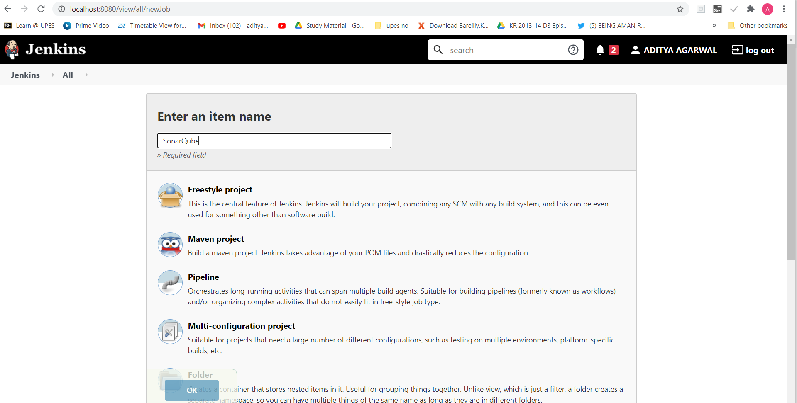

Enter the url of github repository

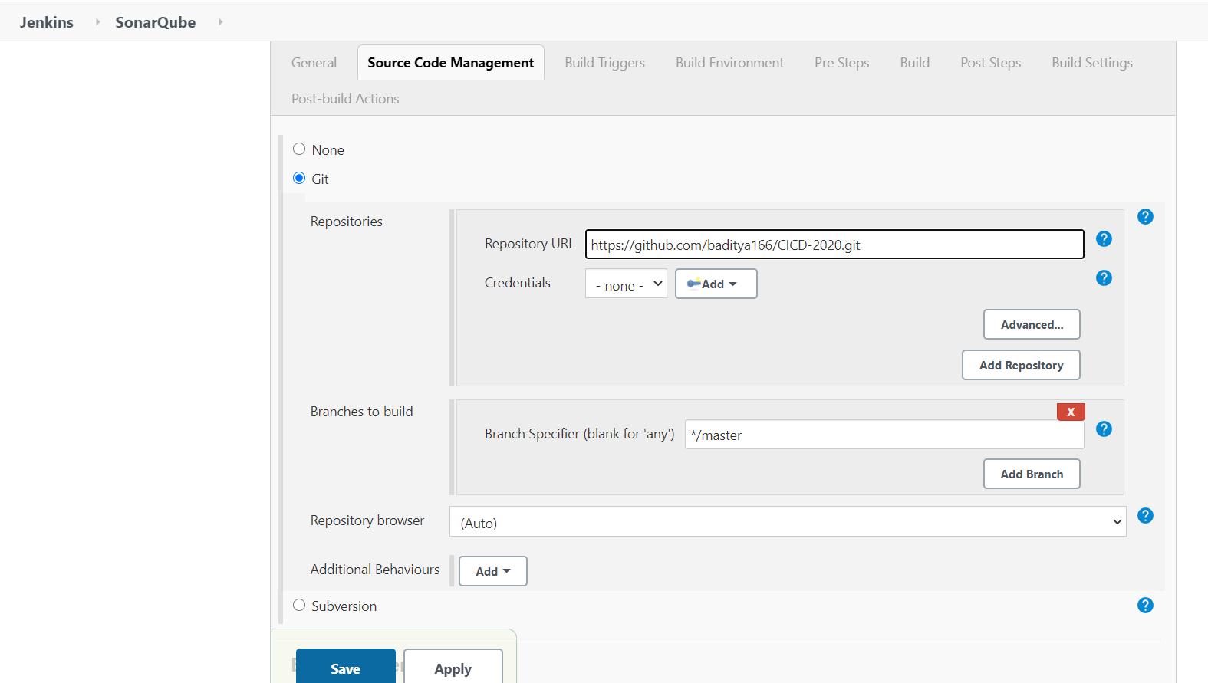

Add the location of pom.xml file

